
How to create a git repository
Step 1: Install Git
- Go to https://git-scm.com
- Download Git for your OS (Windows / macOS / Linux)
- Install it using default settings
Step 2: Create a Project Folder
- Create a new folder on your computer
Example: Devops
- Open the folder
Step 3 : Go to GitHub Home page and click on New to create git repository
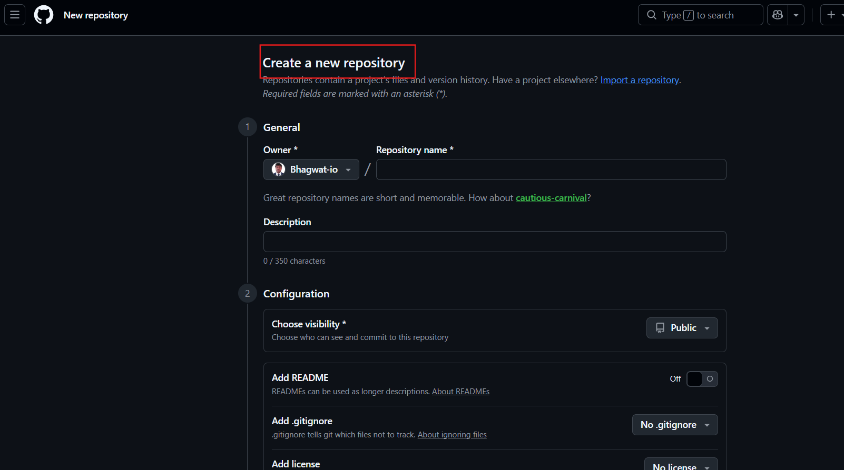

Step 4 : Give Name to repo and add description also configure repo as public or private
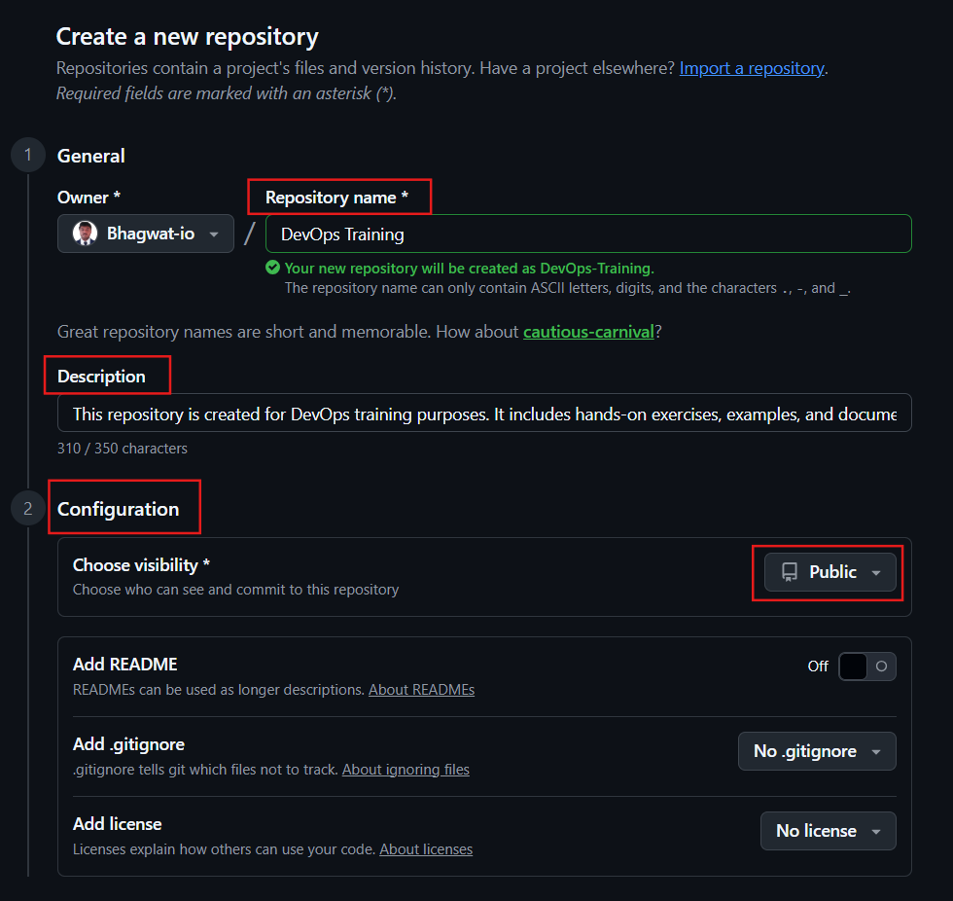
Step 5 : Go to command line and execute git commands
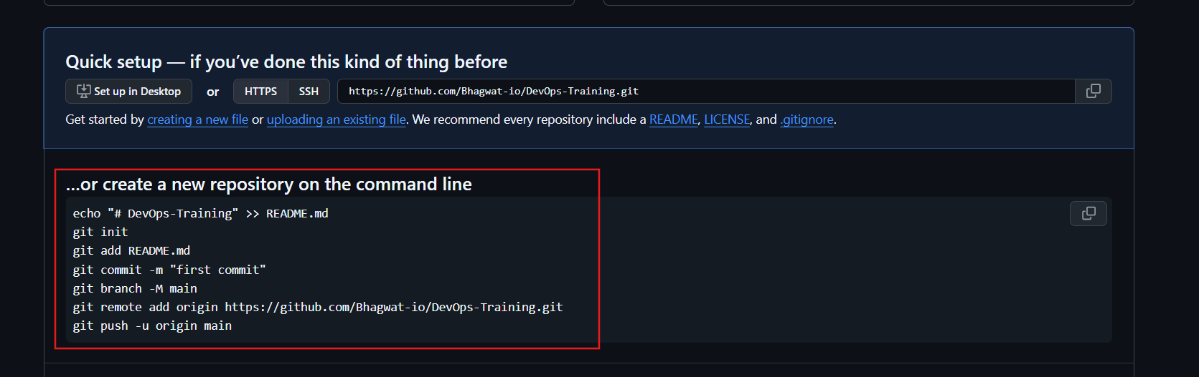

Step 6 : Commands output
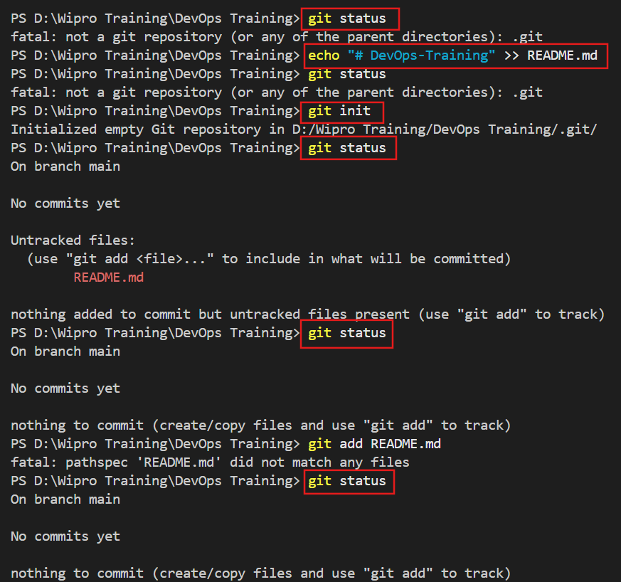
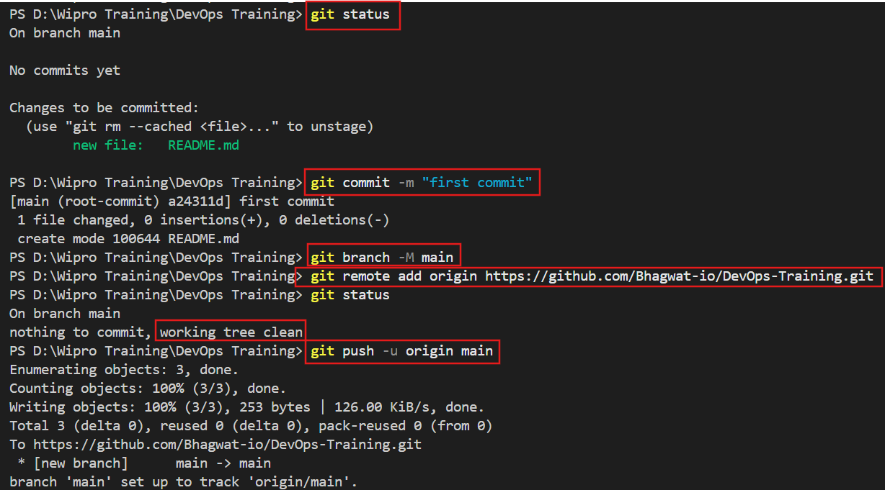
Step 7 : Go to GitHub repo and check it.
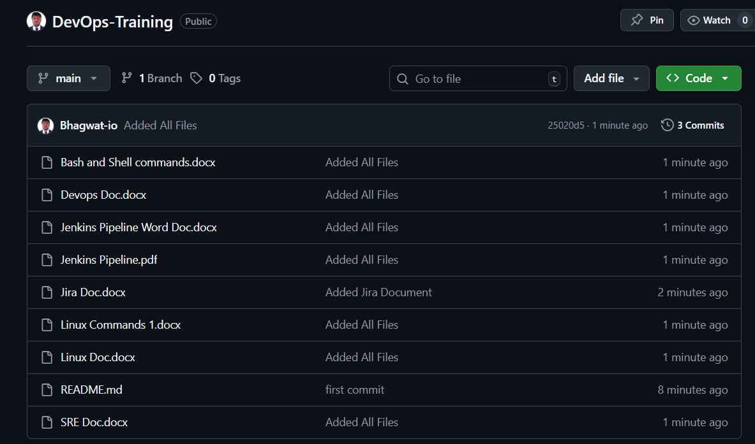

Step 8 : Now Reverse commands from local repo staging area workspace
Staging Area ➜ Workspace
git reset
What it does:
- Removes the last commit
- Files stay in staging area
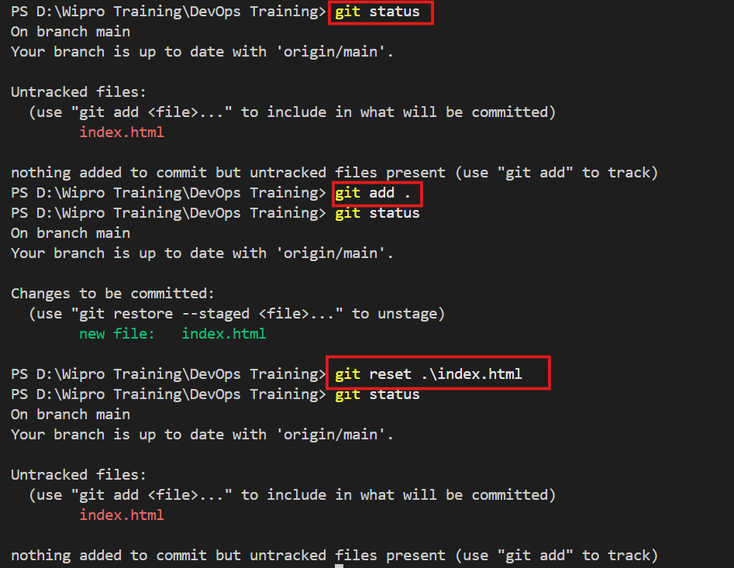
Local Repo ➜ Workspace
git revert AlphaNumeric Number
To find Alphanumeric Number use git log command
- Remove changes from Local Repository (commit)
- Keep changes in Workspace (working directory)

